**Gifts from Advanced International Translations**

**Advanced International Translations** is a supplier of translation management software for freelance translators and translation agencies. Since 1998, AIT has developed 11 software tools for translators and language-service providers.

**ExactSpent is a personal time tracking tool that helps to organize and optimize your work time**

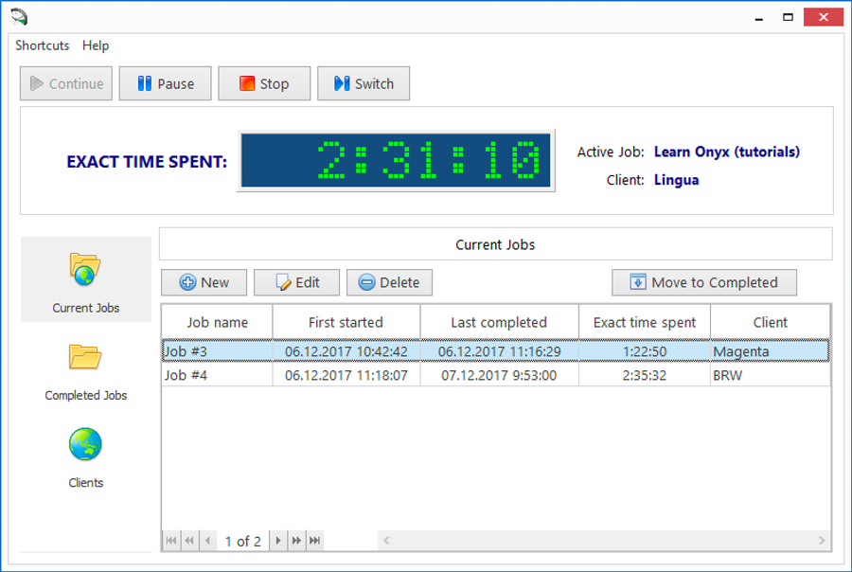

**Track the exact time you spend on each of your jobs**

**Store all your completed and uncompleted jobs**

**Store multiple client records**

**Get summary client data**

**Get summary job data**

**Create reports**

**The tool is integrated with the current version of Translation Office 3000, allowing the two programs to work in tandem.**

Get more info at  **https://www.exactspent.com**

**AceProof performs translation quality checks in bilingual files.**

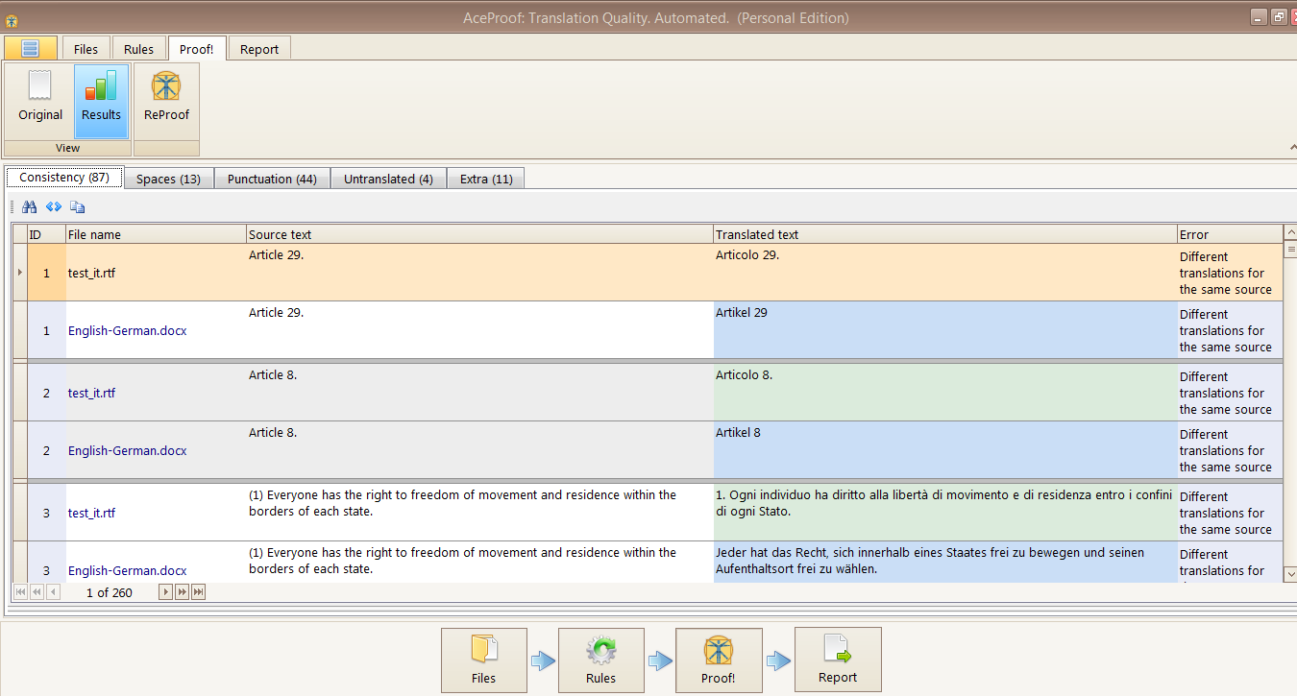

**Check documents in the following formats: DOC(X), RTF, XLS(X), HE (Helium), TMX, TTX, XLF, XLZ, SDLXLIFF, MQXLIFF, MQXLZ**

**Detect inconsistencies between similar translation items**

**Catch common formatting errors:**

* + **consecutive spaces**
  + **consecutive punctuation marks**
  + **differences in the punctuation**
  + **spaces in front of punctuation marks**
  + **discrepancies of HTML/XML tags**
  + **detect different capitalization.**

**Find untranslated words or phrases**

**Distinguish different length of source and target segments**

**Export analysis results to XLSX and PDF**

**Customize the appearance of the program and reports.**

Get more info at **https://www.aceproof.com/**

**Translation Office 3000** is translation management software for managing the workload of freelance translators to ensure you have an efficient and profitable business.

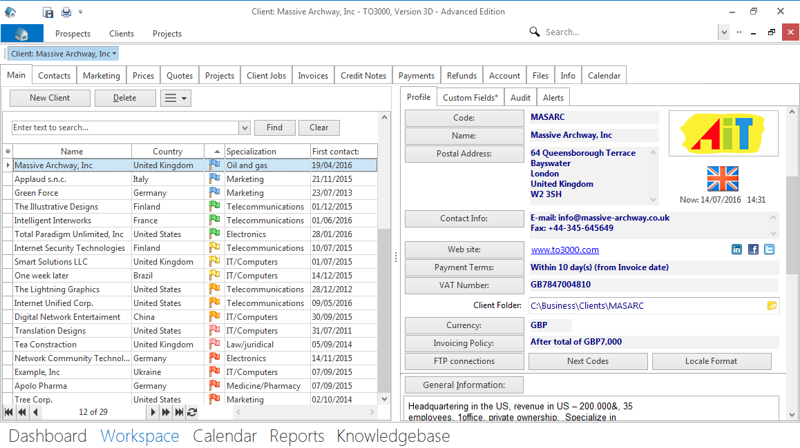

**Build relationships with your prospects and clients. Benefit from a built-in database: update contact information, add in details of clients' businesses, and set milestones for winning new orders.**

**Manage your workflows and keep up with deadlines. Follow the status of translation jobs and identify current, overdue, and completed jobs.**

**Estimate job volumes. Benefit from a built-in AnyCount text count tool.**

**Prepare documents for clients. Generate professional-looking quotes, invoices, payments, credit notes, and refunds.**

**Get timely payments. Track unpaid and uninvoiced jobs.**

**Organize your work-related files. Create structured workflow files, automatically sorted into separate client-related folders.**

**Use reporting. Analyze your productivity and financial performance, including profit and loss, for any period of time.**

Get more info at [**https://www.to3000.com/**](https://www.to3000.com/)

**AnyCount** is a quick and accurate word count tool—the de facto translation industry standard.

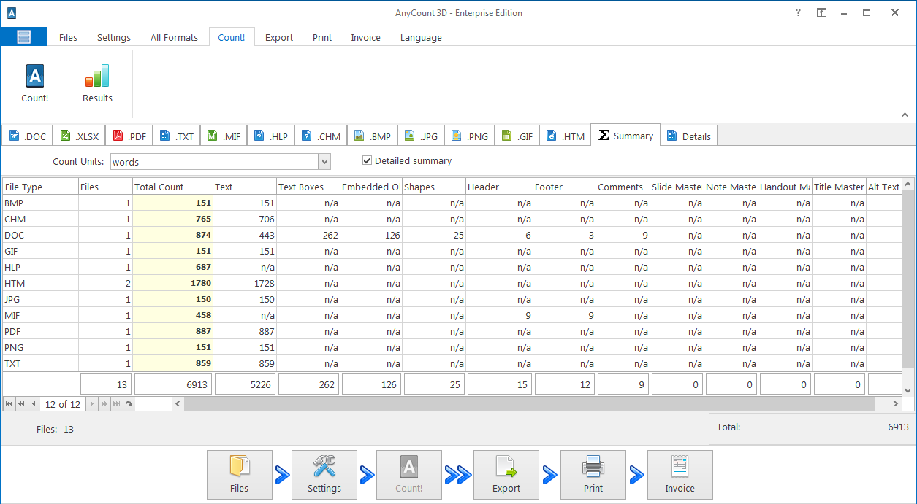

**Count units in 37 file formats. Count words and characters in various file formats such as Microsoft Office, Open Office, HTML+, and Help, and even in images and PDFs.**

**Customize calculation units. Select various units to count: characters with or without spaces, words, lines, or pages.**

**Count in challenging parts of documents. Reveal text in headers, footers, comments, hidden text, embedded objects and linked objects.**

**Grab text from the web. Calculate the volume of material directly from the Internet.**

**Charge for your work. Create invoices based on the counts with the Enterprise Edition.**

Get more info at **https://www.anycount.com/**