Gifts from Advanced International Translations
Advanced International Translations is a supplier of translation management software for freelance translators and translation agencies. Since 1998, AIT has developed 11 software tools for translators and language-service providers.

ExactSpent is a personal time tracking tool that helps to organize and optimize your work time
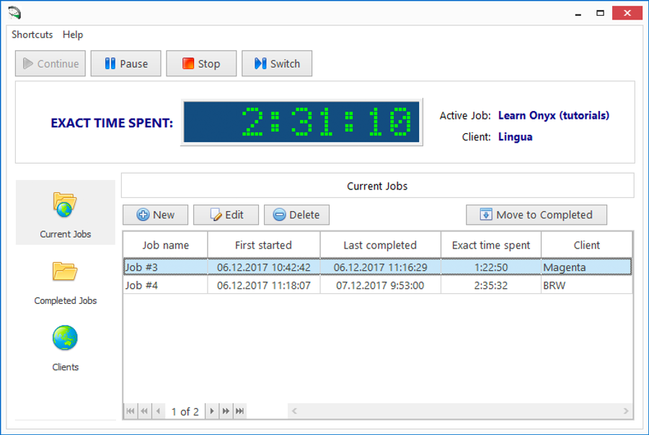
Track the exact time you spend on each of your jobs
Store all your completed and uncompleted jobs
Store multiple client records
Get summary client data
Get summary job data
Create reports
The tool is integrated with the current version of Translation Office 3000, allowing the two programs to work in tandem.

Get more info at https://www.exactspent.com

AceProof performs translation quality checks in bilingual files.
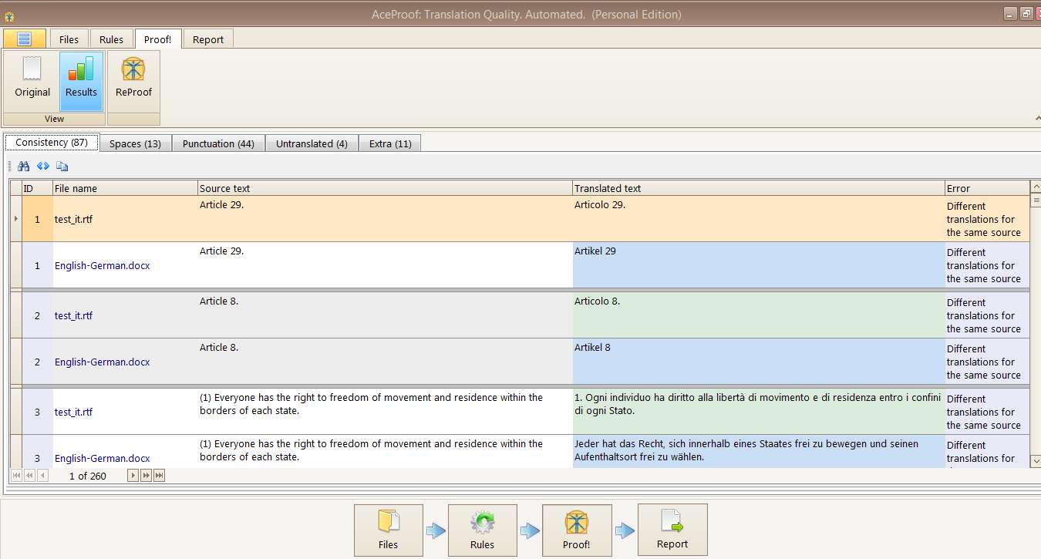
Check documents in the following formats: DOC(X), RTF, XLS(X), HE (Helium), TMX, TTX, XLF, XLZ, SDLXLIFF, MQXLIFF, MQXLZ
Detect inconsistencies between similar translation items
Catch common formatting errors:
  - consecutive spaces
  - consecutive punctuation marks
  - differences in the punctuation
  - spaces in front of punctuation marks
  - discrepancies of HTML/XML tags
  - detect different capitalization.
Find untranslated words or phrases
Distinguish different length of source and target segments
Export analysis results to XLSX and PDF
Customize the appearance of the program and reports.

Get more info at https://www.aceproof.com/

Translation Office 3000 is translation management software for managing the workload of freelance translators to ensure you have an efficient and profitable business.
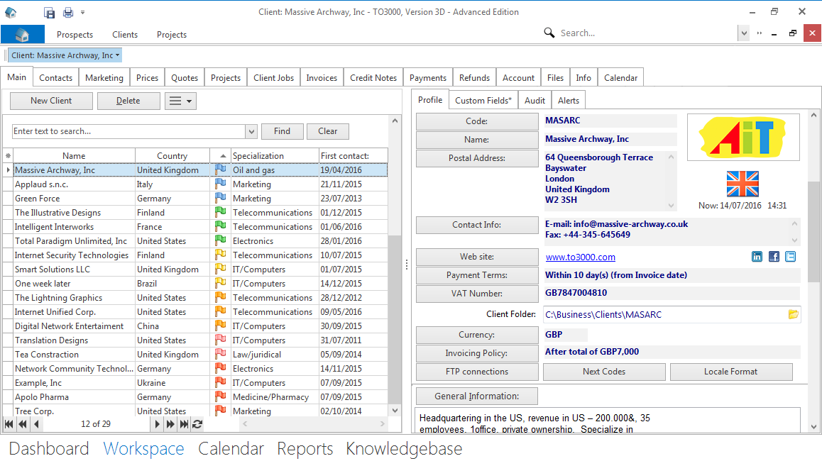
Build relationships with your prospects and clients. Benefit from a built-in database: update contact information, add in details of clients' businesses, and set milestones for winning new orders.
Manage your workflows and keep up with deadlines. Follow the status of translation jobs and identify current, overdue, and completed jobs.
Estimate job volumes. Benefit from a built-in AnyCount text count tool.
Prepare documents for clients. Generate professional-looking quotes, invoices, payments, credit notes, and refunds.
Get timely payments. Track unpaid and uninvoiced jobs.
Organize your work-related files. Create structured workflow files, automatically sorted into separate client-related folders.
Use reporting. Analyze your productivity and financial performance, including profit and loss, for any period of time.

Get more info at https://www.to3000.com/

AnyCount is a quick and accurate word count tool—the de facto translation industry standard.
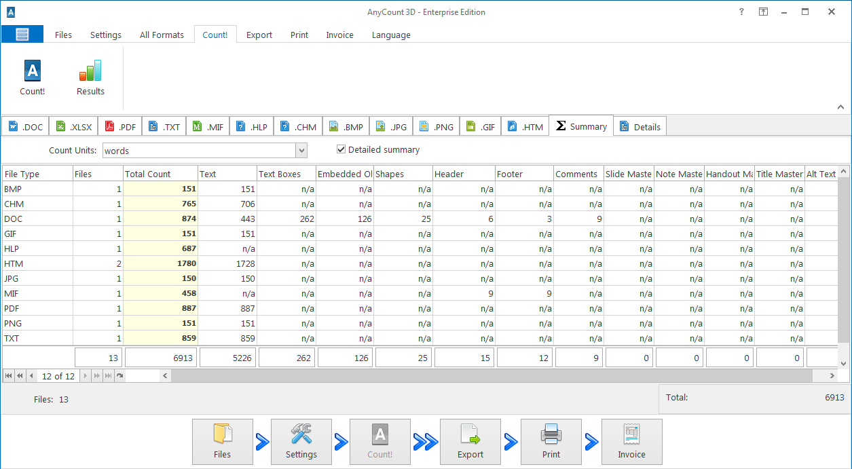
Count units in 37 file formats. Count words and characters in various file formats such as Microsoft Office, Open Office, HTML+, and Help, and even in images and PDFs.
Customize calculation units. Select various units to count: characters with or without spaces, words, lines, or pages.
Count in challenging parts of documents. Reveal text in headers, footers, comments, hidden text, embedded objects and linked objects.
Grab text from the web. Calculate the volume of material directly from the Internet.
Charge for your work. Create invoices based on the counts with the Enterprise Edition.
Get more info at https://www.anycount.com/

